LAB -2

Shell Scripting

Task 1

#!/usr/bin/env bash

echo "Hola Amigo"

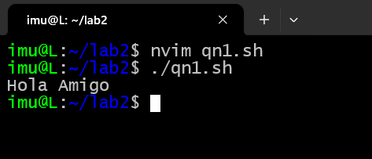

Task 2

#!/usr/bin/env bash

num1=5

num2=6

sum=$((num1 + num2))

echo "sum = $sum"

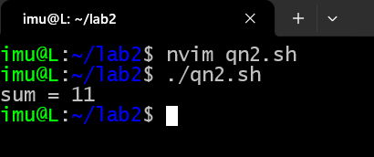

Task 3

#!/usr/bin/env bash

n=0

echo "while loop"

while [ $n -lt 10 ]; do

echo $n

n=$((n + 1))

done

echo "for loop"

for i in {1..4}; do

echo "loop number $i"

done

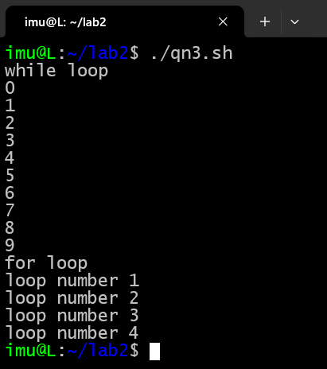

Task 4

#!/usr/bin/env bash

multiply() {

result=$(( $1 * $2 ))

echo $result

}

echo "Enter the first number:"

read num1

echo "Enter the second number:"

read num2

product=$(multiply $num1 $num2)

echo "The product of $num1 and $num2 is: $product"

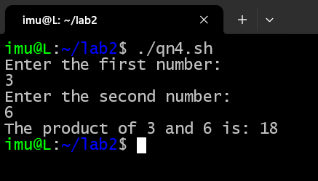

Task 5

#!/usr/bin/env bash

check_command_status() {

command=$1

$command

status=$?

if [ $status -eq 0 ]; then

echo "Command '$command' executed successfully with return code $status."

else

echo "Command '$command' failed with return code $status."

fi

}

command_to_check="ls"

echo "Checking execution status for command: $command_to_check"

check_command_status "$command_to_check"

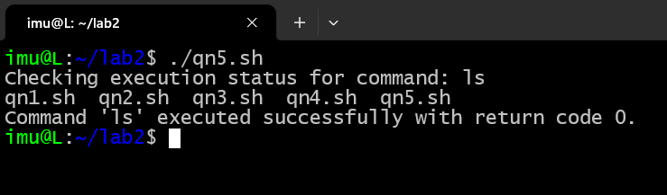

Task 6

#!/usr/bin/env bash

list_files() {

files=$(ls)

echo "$files"

}

count_files() {

num_files=$(ls | wc -l)

echo "Number of files: $num_files"

}

list_files

count_files

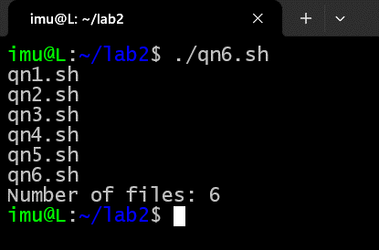

Task 7

Command substitution: substituting date command

#!/usr/bin/env bash

date_now=$(date)

echo "Current date and time: $date_now"

